**TIC TAC TOE GAME**

ASHISH KUMAR  
 2K18/SE/041

CODE:

#include<bits/stdc++.h>

#include<iostream>

#include<cmath>

using namespace std;

void show_grid(string arr[3][3],int n)

{ if(!n)

{ int k=1;

for(int i=0;i<3;++i)

{

for(int j=0;j<3;++j)

{

cout<<"| "<<k<<"| ";

++k;

}

printf("\n--------------");

cout<<endl;

}

} else{

for(int i=0;i<3;++i){

for(int j=0;j<3;++j)

{ if(arr[i][j]=="\0")

{ cout<<"| | ";

}else

cout<<"|"<<arr[i][j]<<"| ";

}

printf("\n--------------");

cout<<endl;

}

}

}

class index

{

public:

int i,j,idx=0;

};

class setsub

{

public:

int sub[3][3];

setsub()

{

for(int i=0;i<3;++i)

{

for(int j=0;j<3;++j)

{

sub[i][j]=0;

}

}

}

};

int check(setsub g1,setsub g2,int c)

{

int w=0;

if(c==2)

{

int dia=0;

for(int i=0;i<3;++i)

{

int num=0;

for(int j=0;j<3;++j)

{

if(g1.sub[i][j]==1)

{ ++num;

}

}

if(num==3)

{ w=1;

return w;

}

}

for(int i=0;i<3;++i)

{if(g1.sub[i][i]==1)

{

++dia;

}

}

if(dia==3)

{ w=1;

return w;

}

dia=0;

for(int i=0;i<3;++i)

{

int num=0;

for(int j=0;j<3;++j)

{

if(g1.sub[j][i]==1)

{ ++num;

}

}

if(num==3)

{ w=1;

return w;

}

}

for(int i=0;i<3;++i)

{

if(g1.sub[i][2-i]==1)

++dia;

}

if(dia==3)

{ w=1;

return w;

}

} else

{

int dia=0;

for(int i=0;i<3;++i)

{

int num=0;

for(int j=0;j<3;++j)

{

if(g2.sub[i][j]==2)

{ ++num;

}

}

if(num==3)

{ w=2;

return w;

}

}

for(int i=0;i<3;++i)

{if(g2.sub[i][i]==2)

{

++dia;

}

}

if(dia==3)

{ w=2;

return w;

}

dia=0;

for(int i=0;i<3;++i)

{

int num=0;

for(int j=0;j<3;++j)

{

if(g2.sub[j][i]==2)

{ ++num;

}

}

if(num==3)

{ w=2;

return w;

}

}

for(int i=0;i<3;++i)

{

if(g2.sub[i][2-i]==2)

++dia;

}

if(dia==3)

{ w=2;

return w;

}

}

return w;

}

void cong(int w,string p1,string p2)

{

if(w==1)

{

cout<<"\t \t \tCongrats "<<p1<<" You WON "<<", "<< "CHEERS"<<endl;

}

if(w==2)

{

cout<<"\t \t \tCongrats "<<p2<<" You WON "<<" ,"<< "CHEERS"<<endl;

} }

int isdraw(setsub g3,int rm1,int rm2)

{ int w=0;

for(int i=0;i<3;++i)

{ for(int j=0;j<3;++j)

{

if(g3.sub[i][j]==1)

{ int c_count=0,z_count=0;;

for(int k=0;k<3;++k)

{ if(g3.sub[i][k]==1)

++c_count;

if(g3.sub[i][k]==0)

++z_count;

}

if(c_count+z_count==3)

{ if(rm1>=z_count)

{ w=1;

return w;

}

}

}

}

}

for(int j=0;j<3;++j){

for(int i=0;i<3;++i)

{

if(g3.sub[i][j]==1)

{ int c_count=0,z_count=0;;

for(int k=0;k<3;++k)

{ if(g3.sub[k][j]==1)

++c_count;

if(g3.sub[k][j]==0)

++z_count;

}

if(c_count+z_count==3)

{ if(rm1>=z_count)

{ w=1;

return w;

}

}

}

}

}

int cd=0,zd=0;

for(int i=0;i<3;++i)

{

if(g3.sub[i][i]==1)

{

++cd;

}

if(g3.sub[i][i]==0)

{ ++zd;

}

}

if(cd+zd==3)

{

if(rm1>=zd)

{

w=1;

return w;

}

}

int c=0;

int z=0;

for(int i=0;i>3;++i)

{

if(g3.sub[i][2-i]==1)

{

++c;

}

if(g3.sub[i][2-i]==0)

{ ++z;

}

}

if((c+z)==3)

{

if(rm1>=z)

{

w=1;

return w;

}

}

for(int i=0;i<3;++i)

{ for(int j=0;j<3;++j)

{

if(g3.sub[i][j]==2)

{ int c_count=0,z_count=0;;

for(int k=0;k<3;++k)

{ if(g3.sub[i][k]==2)

++c_count;

if(g3.sub[i][k]==0)

++z_count;

}

if(c_count+z_count==3)

{ if(rm2>=z_count)

{ w=1;

return w;

}

}

}

}

}

for(int j=0;j<3;++j)

{ for(int i=0;i<3;++i)

{

if(g3.sub[i][j]==2)

{ int c_count=0,z_count=0;;

for(int k=0;k<3;++k)

{ if(g3.sub[k][j]==2)

++c_count;

if(g3.sub[k][j]==0)

++z_count;

}

if(c_count+z_count==3)

{ if(rm2>=z_count)

{ w=1;

return w;

}

}

}

}

}

cd=0,zd=0;

for(int i=0;i<3;++i)

{

if(g3.sub[i][i]==2)

{

++cd;

}

if(g3.sub[i][i]==0)

{ ++zd;

}

}

if(cd+zd==3)

{

if(rm2>=zd)

{

w=1;

return w;

}

}

c=0,z=0;

for(int i=0;i>3;++i)

{

if(g3.sub[i][2-i]==2)

{

++c;

}

if(g3.sub[i][2-i]==0)

{ ++z;

}

}

if((c+z)==3)

{

if(rm2>=z)

{

w=1;

return w;

}

}

return w;

}

int main()

{ cout<<"\t \t \t WELCOME TO 2PLAYER TIC-TAC TOE GAME:"<<endl;

printf("\t \t \t -------------------------------------\n");

cout<<"\nEnter first competitor's name :";

string p1;

cin>>p1;

cout<<"\nEnter second competitor's name :";

string p2;

cin>>p2;

cout<<"\nPlayer1 is : "<<p1;

cout<<"\nPlayer2 is : "<<p2<<endl;

//player1 will choose O,player2 will choose X

int cont=0;

do{

string arr[3][3]={"\0"};

show_grid(arr,0);

int move=5,chan=1;

int rm1=5,rm2=4;

index* arr2 = new index[9];

int aa=0,ab=0,ac=0;

for(int z=0;z<=8;++z)

{

int mod=z%3;

if(mod==1)

{

arr2[z].j=1;

arr2[z].i=aa;

++aa;

}

if(mod==2)

{

arr2[z].j=2;

arr2[z].i=ab;

++ab;

}

if(mod==0)

{

arr2[z].j=0;

arr2[z].i=ac;

++ac;

}

}

setsub g1,g2,g3;

while(move>0)

{

if(chan==1)

{

cout<<"\nMark your move "<<p1<<" to add O"<<endl;

rm1=rm1-1;

}

else{

cout<<"\nMark your move "<<p2<<" to add X"<<endl;

rm2=rm2-1;

}

cout<<"\nChoose a cell numbered from 1 to 9 as above"

" and play :";

while(1)

{

int pos;

cin>>pos;

if(!arr2[pos-1].idx)

{

if(chan==1)

{cout<<"\nafter "<<p1<<"\'s move "<<endl;

chan=2;

arr[arr2[pos-1].i][arr2[pos-1].j]="O";

// printf("--------------\n");

g1.sub[arr2[pos-1].i][arr2[pos-1].j]=1;

//printf("--------------\n");

g3.sub[arr2[pos-1].i][arr2[pos-1].j]=1;

} else{

cout<<"after "<<p2<<"\'s move "<<endl;

chan=1;

arr[arr2[pos-1].i][arr2[pos-1].j]="X";

g2.sub[arr2[pos-1].i][arr2[pos-1].j]=2;

g3.sub[arr2[pos-1].i][arr2[pos-1].j]=2;

}

show_grid(arr,1);

arr2[pos-1].idx=1;

break;

}else

{ if(arr2[pos-1].idx>9||arr2[pos-1].idx<1)

{ cout<<"enter position from 1 to 9 only"<<endl;

} else

cout<<"Sorry :( that place is already filled ,Enter different position"<<endl;

}

}

--move;

}

int w=0;

w=check(g1,g2,chan);

cong(w,p1,p2);

if(w==0)

{

move=4;

while(move>0&&w==0)

{

if(chan==1)

{

cout<<"Mark your move "<<p1<<"to add O"<<endl;

rm1=rm1-1;

}

else{

cout<<"Mark your move "<<p2<<"to add X"<<endl;

rm2=rm2-1;

}

cout<<"choose position"<<endl;

while(1)

{

int pos;

cin>>pos;

if(!arr2[pos-1].idx)

{

if(chan==1)

{cout<<"After "<<p1<<"\'s move "<<endl;

chan=2;

arr[arr2[pos-1].i][arr2[pos-1].j]="O";

g1.sub[arr2[pos-1].i][arr2[pos-1].j]=1;

g3.sub[arr2[pos-1].i][arr2[pos-1].j]=1;

} else{

cout<<"after "<<p2<<"\'s move "<<endl;

chan=1;

arr[arr2[pos-1].i][arr2[pos-1].j]="X";

g2.sub[arr2[pos-1].i][arr2[pos-1].j]=2;

g3.sub[arr2[pos-1].i][arr2[pos-1].j]=2;

}

show_grid(arr,1);

arr2[pos-1].idx=1;

break;

}else

{ if(arr2[pos-1].idx>9||arr2[pos-1].idx<1)

{ cout<<"enter position from 1 to 9 only"<<endl;

} else

cout<<"Sorry :( that place is already filled ,Enter different position"<<endl;

}

}

w=check(g1,g2,chan);

if(w!=0)

{

cong(w,p1,p2);

}

else

{ cout<<endl;

int d=isdraw(g3,rm1,rm2);

if(d==0)

{

cout<<"\t \t \tDRAW "<<endl;

cout<<"\t \t \tWell played !!"<<endl;

w=3;

}

}

--move;

}

}

cout<<endl;

cout<<"Do u want to play it again "<<p1<<" and "<<p2<<"?"<<endl;

cout<<"then enter 1 ,otherwise type 'N0' "<<endl;

cin>>cont;

if(cont!=1){

cout<<"\n \t \t \tTHANK YOU for playing "<<endl;

cout<<"\n \t \t \tHave a nice day :)"<<endl;

}

}while(cont==1);

return 0;

}

OUTPUT:

* When player1 WON

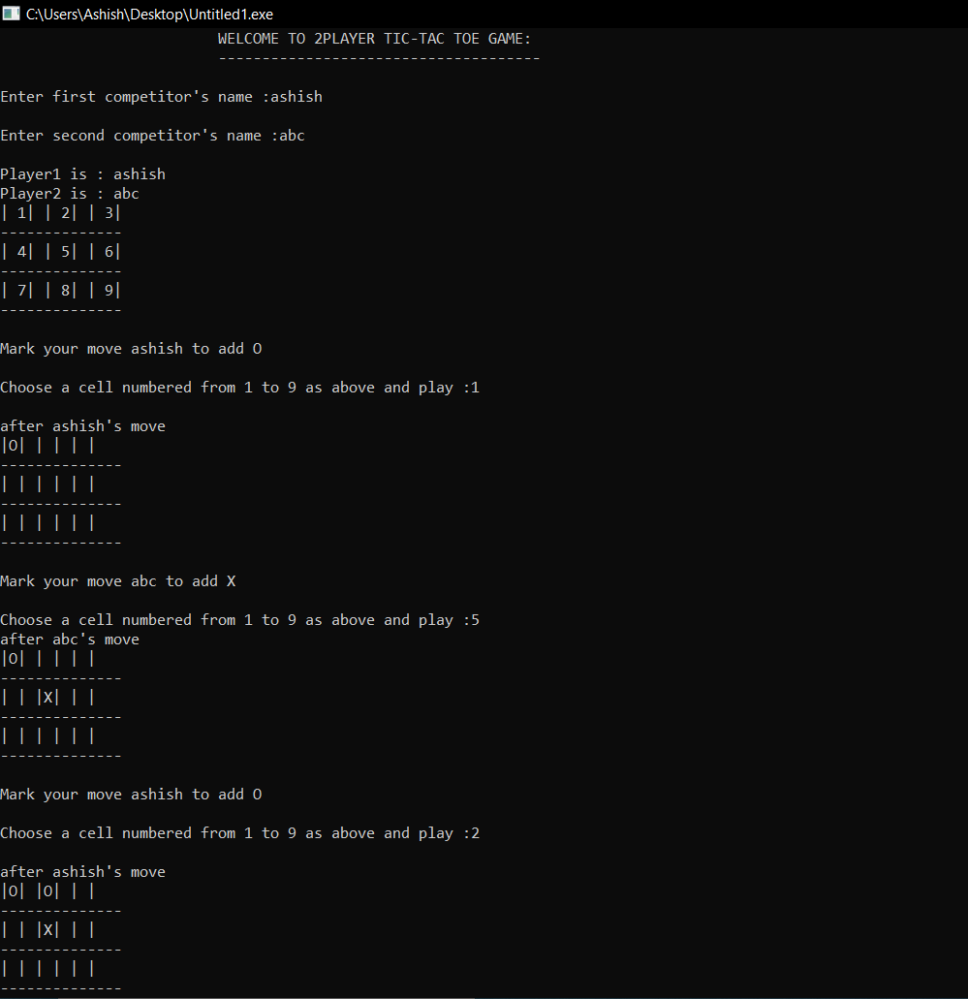  
  
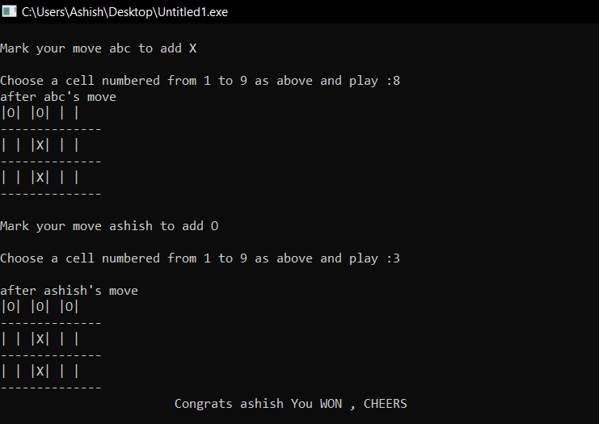

* When player2 WON

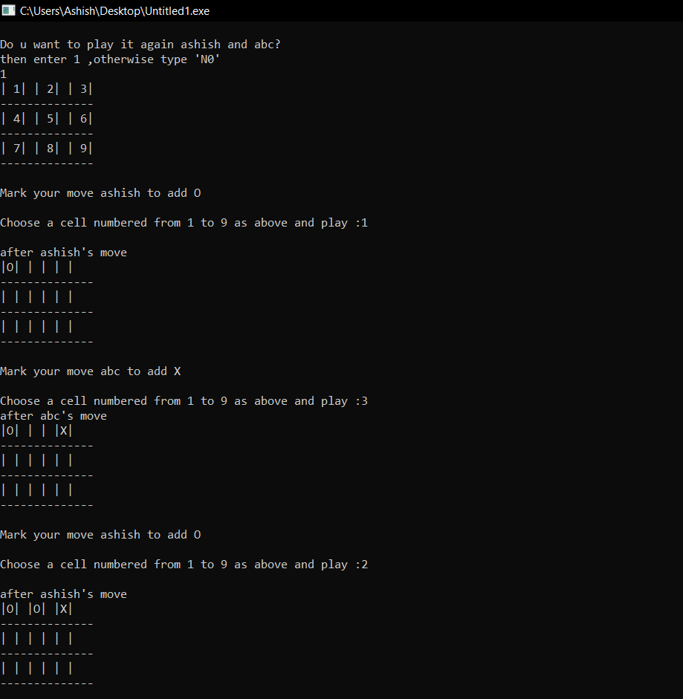

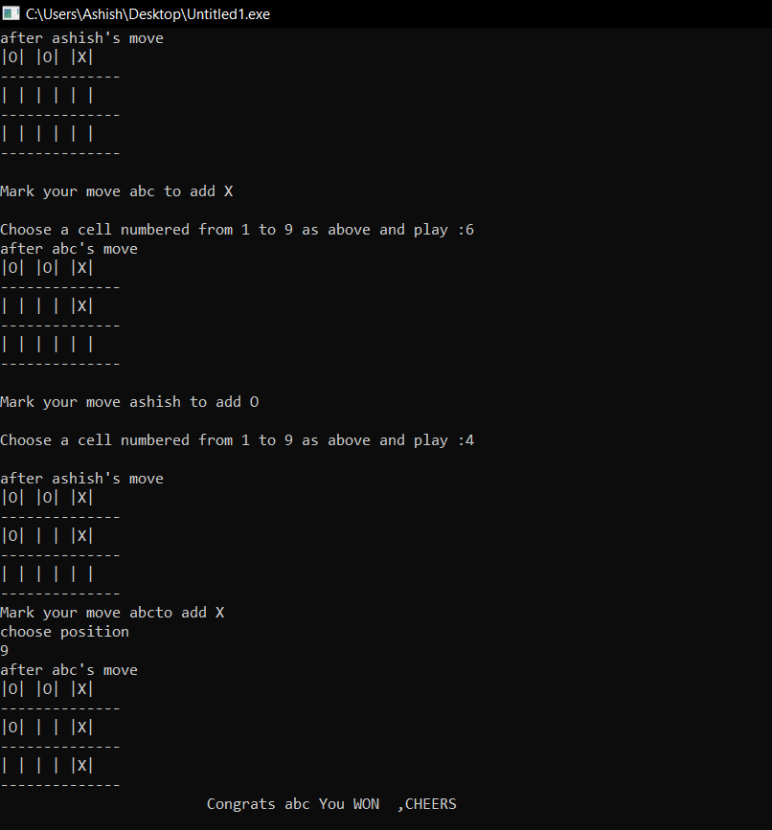

* When match DRAW

